Learning from others: Trustee visits

Trustees have been following up on a list of contacts provided by Marilyn Scott who was engaged by Enfield to advise on fund raising and business planning related to the restoration of Broomfield House.

So far we have spent time with the Trustees at West House in Pinner and the Chief Executive of the Fulham Palace Trust.

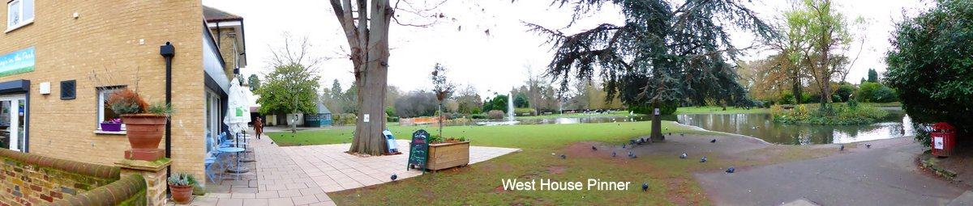

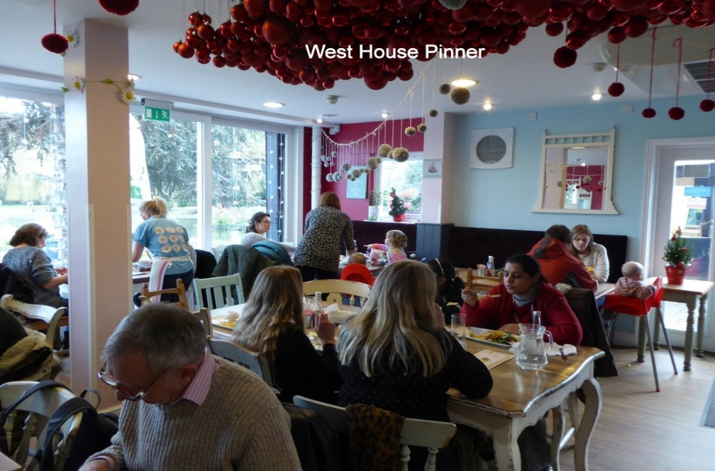

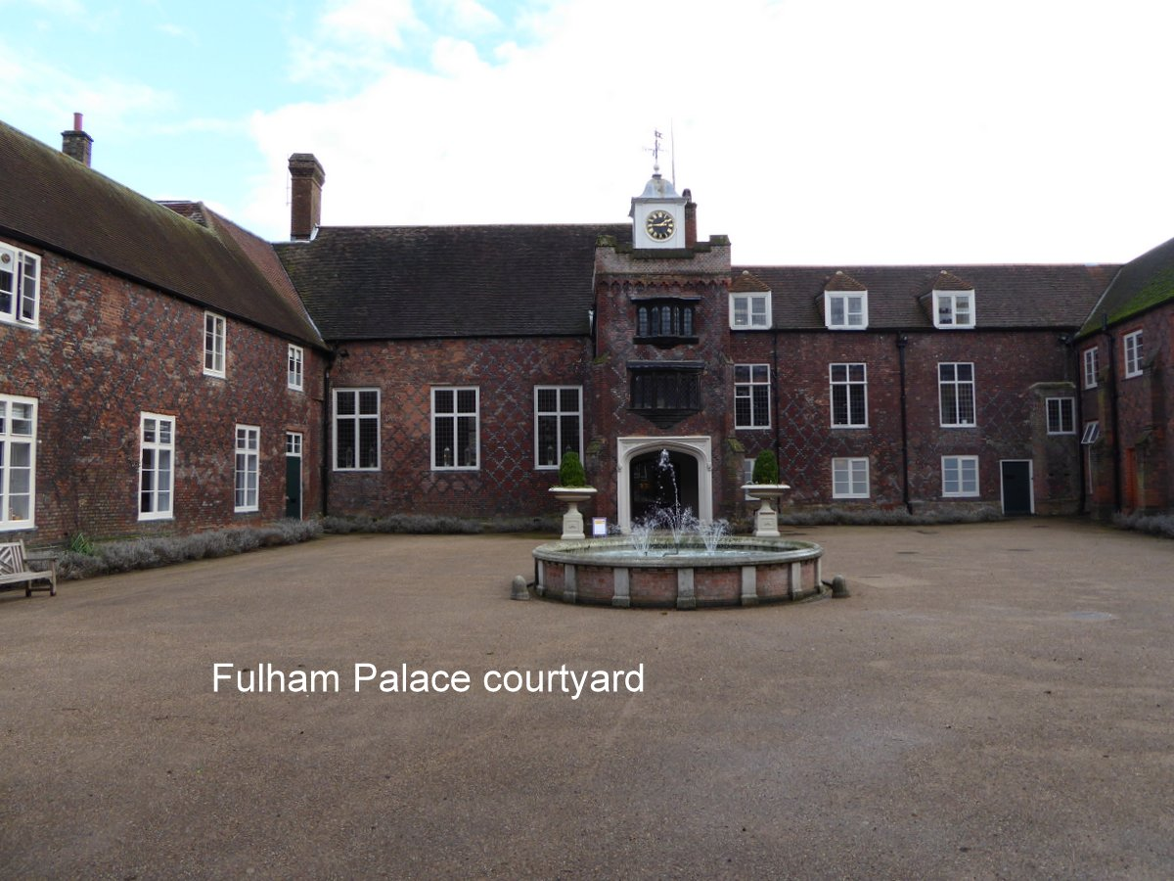

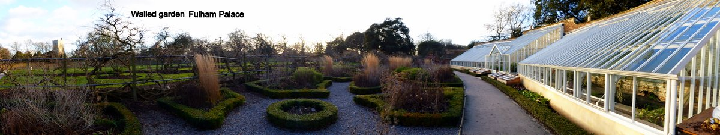

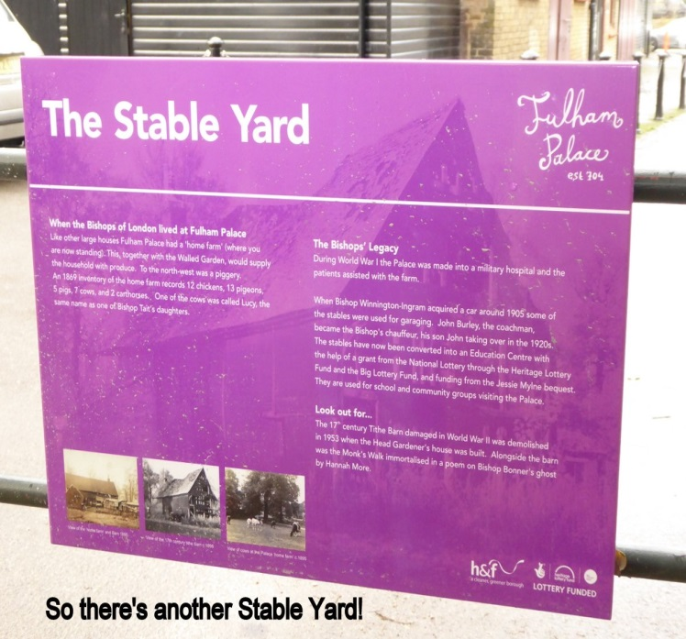

These are, overall, very different to Broomfield House, but discussions reveal aspects of their situations which could be relevant, and in particular their mix of revenue earning and public access.. Possible future visits include to Arundel Museum

Trustees have previously visited a number of historic properties, for example Clissold Park and House in Hackney and Valentines Mansion and Gardens in Redbridge. We may revisit some properties to see how things are going; it appears that some trusts are facing challenges to their original business plans.

